Flower Classification Using SVM & SGD

Bhargava Reddy Gangireddy  
*CS 5710-Machine Learning*  
*University of Central Missouri Lee's Summit, USA*  
bxg12620@ucmo.edu

Venkata Sowmya Tellapragada  
*CS 5710-Machine Learning  
University of Central Missouri Lee's Summit, USA*  
vxt17410@ucmo.edu Jahnavi Danda  
CS 5710-Machine Learning  
University of Central Missouri Lee's Summit, USA  
jxd40890@ucmo.edu

Rahul Lakum  
*CS 5710-Machine Learning**University of Central Missouri Lee's Summit, USA*  
rxl65220@ucmo.edu

***Abstract*— The advancement of the recognition of rare plant species will be beneficial in a variety of fields, including the pharmaceutical industry, botany, agriculture, and international trade activities. It was also tough because there is such a wide variety of flower species, and it is tough to classify them when they can be extremely similar to one another. This subject has therefore already become critical in this context. For the purposes of learning the dataset, this project used a classification system for flower images that are built on machine learning-based SVM and SGD serving as a primary classifier to learn the dataset. Machine learning techniques have recently emerged as the most advanced technology for dealing with such problems. First, we used a classification model to improve the performance of flower image classification by using SVM for feature extraction followed by SGD algorithms for classification. Second, we demonstrated how image augmentation can be used to improve the performance of a computer simulation. Last but not least, we compared the performances of machine-learning classifiers such as support vector machines. In the study, we evaluated our classification system by comparing it to our datasets. The images of flowers in this dataset total 4242 images. The data was gathered from various sources, including Flickr, Google Images, and Yandex Images. We discovered that the SVM Classifier had the highest accuracy at 98.91 percent.**

**Keywords: Flower species, SVM, sparse model, SGD, Recognition, Accuracy, Machine learning**

# Introduction

The most important producers on the planet, flowers can be found in a wide range of climates and habitats, making them the most versatile of all plant life. They also continue to play an important role in the food chain, as they provide food for nearly all of the insect species on the planet. In addition to this, they play an important role in the food chain, and their healing properties can be used to create a wide range of pharmaceutical products. As a result, having a thorough understanding of flowers and their various species is extremely beneficial when it comes to identifying new or rare plant species. Aside from that, many plants may be damaged because they are considered harmful to one's farmland or may be sold at extremely low prices if they are not protected.

All of this occurs as a result of insufficient recognition of the plant species' existence. However, it is a real phenomenon that many of the plants that grow in nature can also be grown in a laboratory setting. Increased recognition capacity of numerous endemic plant species, such as elecampane and verbascum thapsus, whose life is restricted to a specific area and which can only be grown under specific climatic conditions, will also help the pharmaceutical industry to develop further.

There are approximately 250,000 named species of flowers in the world, and there are many different types of flowers. The majority of people see flowers on a daily basis, but they are unable to identify them. They consult with flower experts, peruse flower books, or conduct keyword searches on the Internet in order to determine the names of these flowers. By categorizing flower images, it is possible to identify flower names in a simple and expedient manner. Particularly relevant today, given the widespread use of mobile digital cameras throughout the world. Making a caption for a flower image and sending it to a flower recognition system that classifies flower images will assist people in the identification of flowers.

Some approaches to flower identification have been proposed, and some of them are as follows: Pre-processing, segmentation, hand-design feature extraction, and classification are the four steps that are typically followed in this process. Given that flower images have complex backgrounds, these tasks are time-consuming, and the accuracy of the results is still low, particularly when there are a large number of species to consider. Using deep Convolutional Neural Networks (CNNs), researchers have recently demonstrated a number of successes in a variety of topics in the field of computer vision, including object detection, image segmentation, and image classification, among others.

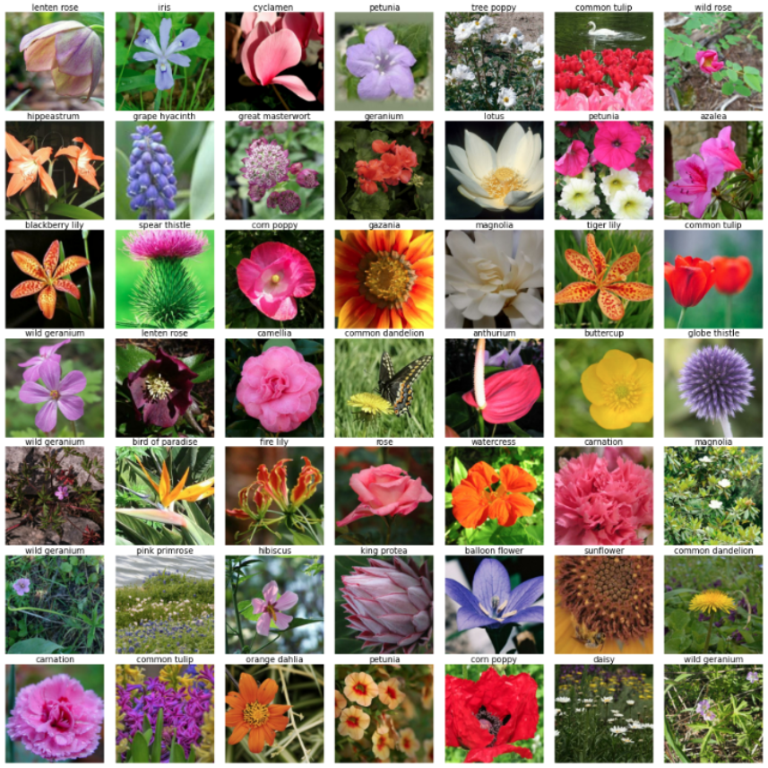

Fig 1. Different flower species

Following the extraction of flower image feature vectors, the proposed approach categorizes the images using SGD model and Support Vector Machine (SVM) classification (SVM). The classification approach is evaluated through the use of five different flower categories. As a result of conducting this evaluation, the results show that the proposed approach is capable of classifying the flower name with a high degree of accuracy. A flower classification system of this type can be applied in a variety of real-world situations. For example, it can be used as an interactive educational tool to improve learning methods for both young and old people, as well as for adults.

All of the remaining pieces of paper have been divided into six sections for your convenience. Introduction: In Section I, we provide a high-level overview of the subject matter. Section II discuss about the motivation. Section III contains the main contributions and objectives of the paper. Providing an overview of the literature review is covered in Section IV. Section V contains a more in-depth discussion of machine learning-based classifiers, their performances, and the datasets that they use. The findings are presented in Section VI. Section VII presents a synopsis of our findings and conclusions as a result of our investigation. Additionally, the subject of future work is covered in this section.

# MOTIVATION

There are many different types of flowers, and there are an estimated 250,000 species of flowers worldwide. The majority of people routinely walk by flowers without being able to identify them. They consult floral experts, go through flower books, or use keyword searches on the Internet to learn the names of these blooms. By categorizing flower images, it is possible to swiftly and simply determine flower names. It is particularly important given the widespread use of mobile digital cameras in today's world. By adding a commentary to a flower image and uploading it to a system that categorizes flower photographs, people can be assisted in their quest to identify flowers. These tasks take a lot of time, and the results are still inaccurate, especially when there are several species to consider because flower images have complex backgrounds.

Using machine learning, researchers have recently demonstrated a number of successes in a variety of topics in the field of computer vision, including object detection, image segmentation, and image classification, among others.

Motivation is to create a flower classification system with at most accuracy & with less computational and time-consuming method.

Following the extraction of flower image feature vectors, the proposed approach categorizes the images using the Support Vector Machine (SVM), and Stochastic Gradient Descent (SGD) with most accuracy. The classification approach is evaluated through the use of five different flower categories. As a result of conducting this evaluation, the results show that the proposed approach is capable of classifying the flower name with a high degree of accuracy. A flower classification system of this type can be applied in a variety of real-world situations. For example, it can be used as an interactive educational tool to improve learning methods for both young and old people, as well as for adults.

# MAIN CONTRIBUTIONS & OBJECTIVES

Dataset collection: Rahul Lakum & Jahnavi Danda

Dataset loading and preprocessing coding: Bhargava Reddy & Rahul lakum

Algorithm implementation coding: Bhargava Reddy, Sowmya Tellapragada, Jahnavi Danda

Documentation: Sowmya Tellapragada

Objectives: Objective of this project is to achieve better accuracy with less training images.

# RELATED WORK

Nilsback et al. [4] pointed out that the most important factors to consider when categorizing flowers are colour and type unit of measurement. The flower is segmented using a threshold-based method, and texture options are extracted as a result. This includes the colour texture moments (CTMs), grey level co-occurrence matrix (GLCM), and scientist responses, unit of measurement. A probabilistic neural network is used to apply the measures of choice for classification. Using principal component analysis, Y. Yoshioka et al. [5] quantified the range of leaf colours. On the petals, they considered the first five principal components (PCs) of the largest square. T. Saitoh et al. [6] detailed an automated method for identifying a flower in bloom, which relied on a method for removing the flower's bottom parts.

Piecewise linear discriminate analysis was utilised for recognition by T. Saitoh et al. [7]. Fadzilah Siraj et al. [8] have made accessible a method for classifying flowering plants native to Malaysia. This research demonstrated how NN may be combined with a visual approach to produce a variety of floral images as inputs. Provision regression has a 26.8% success rate in making predictions. Pavan Kumar Mishra et al. [9] provide a semi-automatic method for plant identification using digital photographs of leaves and flowers. A multi-class system is presented, with colour, form volume, and cellular properties serving as the basis for the many categories. The flower identification system presented by Tanakorn Tiay et al. [10] used an image processing system that was supported by the system. In order to train the KNN for flower classification, they employed edge and colour properties of floral images. About 80% accuracy may be expected from this procedure. Using an ANN-based technique [11], Dr. S.M. Mukane et al. intended to capitalise on the Flower Classification problem. Gray level co-occurrence matrix and separate rippling rework were among the textural possibilities on which the intended method depended (DWT).

Flowers may be detected and identified using the SSD model, which was introduced by Mengxiao Tian et al. [6]. The experiment made use of the floral data collection originally created and shared by Oxford University. Experimental findings show an average accuracy of 83.64 percent using the Pascal VOC2007 evaluation standard and 87.4 percent using the Pascal VOC2012 evaluation standard.

In their study, Swati Kosankar et al. [7] demonstrated experimental implementation based on the MobileNet model and the TensorFlow library. They retrained the 102 datasets belonging to the floral category and improved accuracy to 70.6%. In a recent paper, Hazem Hiary et al. [8] published their work on the automated segmentation of floral photos using bounding boxes to identify the blossom's outline. Furthermore, they have validated their technique on three widely-known flower datasets and employed a CNN classifier to differentiate between the various flower varieties. A total of 81%, 78.7%, and 77.3% were correctly classified. Using multi-scale representations of FPN, Isha et al. [9] and Tao Kong et al. [10] reformulated the feature reconfiguration procedure. The model's efficacy was also improved by combining low-level and high-level characteristics. To enhance the performance of deep learning tasks with limited training data, Weifeng Ge et al. [16] used a transfer learning strategy. Full-image convolutional features were learned using end-to-end RPN detection networks developed by Shaoqing Ren et al. [16]. A Fast R-CNN was used to provide good region recommendations for object detection, and the two networks were combined by sharing convolutional features. The recognition of tiny objects in optical remote sensing pictures was achieved by Yun Ren et al. [19]. In [22], Longsheng Fu et al. used a deep convolutional neural network to recognise kiwifruit.

Using SGD methods, ZFNet, and back-propagation, a faster R-CNN was trained from start to finish. The kiwifruit detector has an AP of 89.3 percent. The Faster R-CNN for traffic sign identification in actual traffic circumstances was given by the illustrious Shao et al. [22]. The RPN is intended to be built on SGWs and MSERs. By employing the VGG16 and an enhanced Faster-RCNN, Shaoming Zhang et al. [20] were able to execute ROI pooling on a more extensive feature map inside an RPN. Classification accuracy was examined across techniques of combination, evaluation, and their parameters in a study by Marco Seeland et al. [21]. Also included are three different flower datasets (Oxford Flower 17, 102, and Jena Flower 30) used to extract a wide range of attributes, such as the flowers' shapes and colors. There is a 67.7% accuracy, a 79.9% accuracy, and a 49.9% accuracy.

# Methodology

## *Datasets*

The images of flowers in this dataset total 4242 images. The data was gathered from various sources, including Flickr, Google Images, and Yandex Images. We can use this dataset to identify plants in a photo using their characteristics.

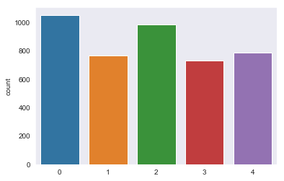

Fig 2. Five different categories of flowers count

The images are categorized into five categories: chamomile, tulip, rose, sunflower, and dandelion, among others.

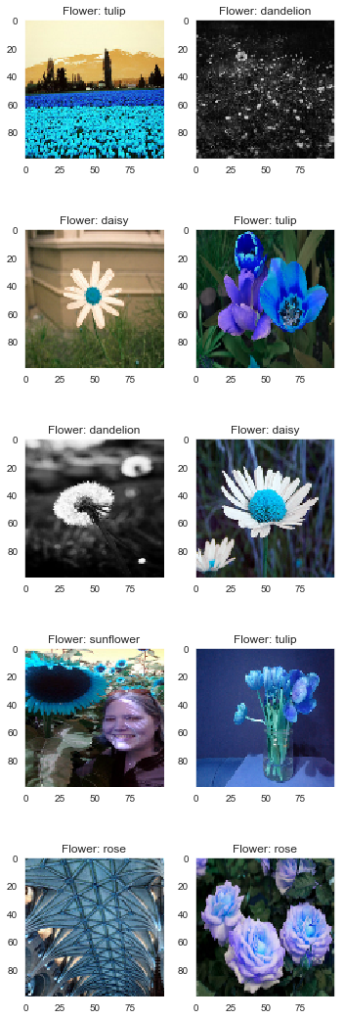



Fig 3. Dataset Sample

There are approximately 800 photos in each class. The photos are not of high quality, with a resolution of approximately 320x240 pixels. There is no single size for photos; instead, they have a variety of sizes and shapes!

## *Data Preparation*

Preprocessing data is one of the most crucial processes in the machine learning process. It is the most crucial stage in improving the accuracy of machine learning models, and it is the most time-consuming. In data preprocessing, the raw data is cleaned up and transformed into clean data, which can then be utilized to train a machine learning model.

The floral areas of a photograph are typically overlaid on a complex background, making it difficult to distinguish them from the background. To select the ROI (Region-Of-Interest) on flower images, we use saliency-segmentation-based approaches, which are described in detail in this paper. Pre-processing techniques are depicted in Fig. 4 in their overall flow. First and foremost, we adapt a saliency extraction method, which is a common segmentation technique, to our needs (e.g., mean-shift algorithm).

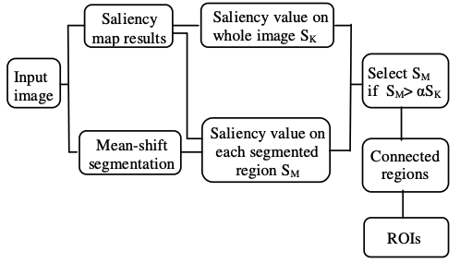

Fig 4. The proposed pre-processing to select the regions of interest (ROI) of flowers.

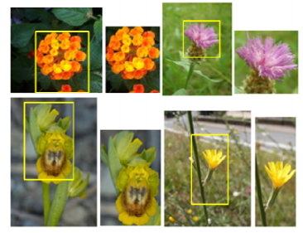

Fig 5. Flower images and detected ROIs.

In this case, the segmented region is chosen on the basis of the condition that the corresponding saliency value is sufficiently large. The connected-region techniques are then used to merge the regions of interest into a single interest of regions. Figure 5 shows ROIs (left panel) whose top-left and bottom-right points form a rectangle on the original images and ROIs (right panel) that do not (right panel).

*C. Modeling (Data Description)*

**I. SVM**

Flower images are typically captured against a complicated background that includes a variety of objects in the foreground. Even SVM can be applied directly to these images in order to evaluate the effect of background on flower identification; however, this is not recommended. On flower images, we apply a number of different preprocessing techniques.

The results are limited to flower regions extracted from a natural image. With many applications in various fields, support vector machines (SVMs) have proven to be an effective tool for classification and pattern recognition in a variety of situations. On the basis of the risk minimization principle, SVM can be defined as a constrained margin maximization problem. It is formulated as a convex quadratic programming problem, which can be solved quickly and effectively.

Standard SVM, on the other hand, which focuses on minimizing the hinge loss function and the L2 norm, only produces sparsity for the dual variables and not for the primal variables. The use of support vector machines with other penalties, such as the L1 penalty and the elastic net, for feature selection and prediction has been proposed to deal with the big omics data problem with a large number of features. These methods, on the other hand, are dealing directly with the primal variables. They become computationally inefficient when the number of features (genes) is large, as is common in big omics data sets.

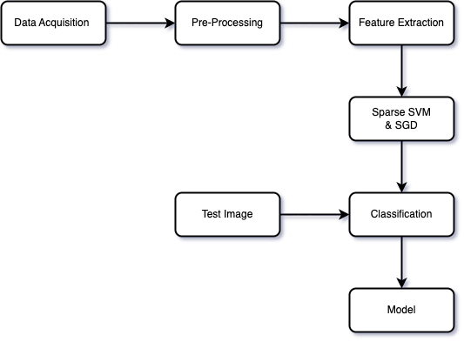

Fig 6. Workflow

Flower images are typically captured against a complicated background that includes a variety of objects in the foreground. Even better, Machine Learning can be applied directly to these images in order to evaluate the effect of background on flower identification; we use some preprocessing techniques on flower images in order to accomplish this. The results are limited to flower regions extracted from a natural image. SVM and SGD are one of the most well-known machine learning approaches.

**II. Random Forest**

Random Forest is a supervised machine learning technique that develops and merges several decision trees to form a "forest." Another form of the algorithm used to categorize data is a decision tree. In the most basic sense, it is similar to a flowchart that depicts a clear trail to a choice or consequence; it begins at a single point and then branches off into two or more directions, with each branch of the decision tree presenting several potential outcomes. Random Forest generates many decision trees, which are then combined to provide a more accurate forecast.

The Random Forest model is based on the idea that numerous uncorrelated models (individual decision trees) perform far better as a group than they do individually. When Random Forest is used for classification, each tree provides a classification or "vote." The categorization with the most "votes" is chosen by the forest. When utilizing Random Forest for regression, the forest chooses the average of all tree outputs.

**Step 1:** Select random K data points from the training set.

**Step 2:** Build the decision trees associated with the selected data points (Subsets).

**Step 3:** Choose the number N for the decision trees that you want to build.

**Step 4:** Repeat Steps 1 & 2.

**Step 5:** For new data points, find the predictions of each decision tree, and assign the new data points to the category that wins the majority votes.

Random Forest (RF) is a collection of supervised learning techniques for classification and regression [10] used in predictive modeling and machine learning. It takes the findings and predictions of many decision trees and settles on the mode (the value that occurs most often in the collection of decision tree results) of the classes or the mean forecast as the optimal output.

By separating the data into a training set and a test set, RF can effectively do its task. Then, pull numerous samples at random from the data used for training. Next, split each choice into its two best-looking daughters using the decision tree. The most popular forecast is then chosen as the final outcome by doing another round of voting. Random Forest's primary hyperparameters are adjusted to either improve the model's predicting abilities or to speed up the training process [11]. When dealing with this problem set, increasing the number of trees may improve performance and make forecasts more stable, but at the cost of increased processing time. Using a larger feature set and fewer leaves may also help the algorithm perform better, as may splitting internal nodes only when they are explicitly required. After the training phase is complete, the model may be employed on a different dataset. By following these steps, we may make educated guesses about their forecasts and evaluate them against theoretical norms.

**III. Stochastic Gradient Descent**

Gradient Descent (GD) is a basic optimization process that seeks to discover the coefficient of (f) under a condition that minimises the cost margin, where (f) represents the cost of inaccurate predictions. The cost function uses the expected outcomes for each training set sample to estimate the value of a collection of coefficient values. Following the steps described above, the algorithm will try various coefficient values in search of a cheaper price, and then it will update the coefficient using a learning rate value to convert it on the following iteration.

A very high cost is incurred, multiplied by the full training dataset for each iteration, while performing such a computation. Contrarily, SGD alters the coefficient after each training sample rather than all at once.

The Stochastic Gradient Descent (SGD) Classifier is an optimization technique that is used to identify the values of function parameters that minimize a cost function. The method is quite close to the classic Gradient Descent process. However, it only computes the derivative of a single random data point's loss rather than all of the data points (hence the name, stochastic). As a result, the method is substantially quicker than Gradient Descent.

Gradient descent is used to minimize a cost function in a nutshell. Gradient descent is one of the most used optimization methods, and it is by far the most frequent approach to optimizing neural networks. However, we may employ various methods, such as Logistic Regression and linear Support Vector Machines, to improve our linear classifier. Because the minimum of the Logistic Regression cost function cannot be determined directly, we attempt to minimize it using Stochastic Gradient Descent, also known as Online Gradient Descent. For each training observation encountered, we decrease the cost function towards its minimum.

## *D. Validation Method*

Precision: Precision is a measure of a classifier's ability to avoid labeling a true negative observation as a positive observation.

Precision=TP/(TP+FP)

Recall (Sensitivity): The ability of a classifier to find positive observations in a dataset is measured by the recall of the classifier. If you wanted to be absolutely certain that you found all of the positive observations, you could increase recall to the maximum.

Recall=TP/(TP+FN)

# Results

The results of this study's analysis were observed with the test dataset, which confirmed the findings of the study. The SVM classifier was used to classify the new feature set, and the accuracy rate for classification was 42 percent overall.

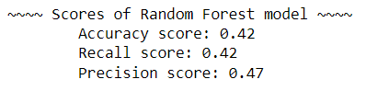

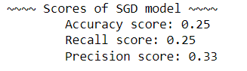

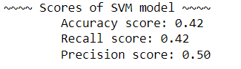

Fig 7. Accuracy, Recall, Precision of three models

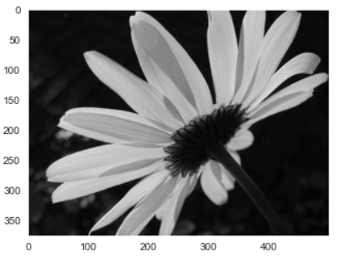



Fig 8. Test Results

# Conclusion and future work

The classification of flower species is a time-consuming and difficult endeavor. The presence of herbs, leaves, and other vegetation on and around the flowers makes it more difficult to distinguish between flower species. When it comes to classifying flower species, traditional methods have proven effective. The main goal of the Machine learning models was to extract the features that were discovered when the feature sets obtained through different methods of feature selection intersected with each other. These characteristics are regarded as more stable characteristics, and the findings of the study lend support to this notion.

A total of 98.91 percent of the flowers in the five flower classes were correctly identified as such. In future studies, we will use attention modules to examine different datasets from different perspectives. The main goal of this model was to extract the features found at the intersection of feature sets obtained using different feature selection methods, which was accomplished through a variety of methods. The results of the experiment revealed that the proposed approach contributes less to the accuracy of classification than the existing approach. We need to improve the accuracy of the model by incorporating neural networks and data augmentation.

SVM achieves better accuracy, recall score & precision than SGD.

# References

1. Patel, Sanskruti & Patel, Isha. (2019). Flower Identification and Classification using Computer Vision and Machine Learning Techniques. International Journal of Engineering and Advanced Technology. 8. 277-285. 10.35940/ijeat.E7555.088619.
2. Jana Wäldchen, Michael Rzanny, Marco Seeland, Patrick Mäder, “Automated plant species identification—Trends and future directions”, Pols, Computational Biology, April 5, 2018.
3. Isha Patel, Sanskruti Patel, Atul Patel, “Analysis of Various Image Preprocessing Techniques for Denoising of Flower Images”, International Journal of Computer Sciences and Engineering, Vol.-6, Issue-5, May 2018, pp. 1012-1018.
4. Huthaifa Almogdady, Dr. Saher Manaseer, Dr.Hazem Hiary, “A Flower Recognition System Based On Image Processing and Neural Networks”, International Journal of Scientific & Technology Research Volume 7, Issue 11, November 2018.
5. Kukade, Manoj & Karve, Tanay & Gharpure, Damayanti. (2019). Identification and Classification of Spices by Machine Learning. 1-13. 10.1109/ICISGT44072.2019.00015.
6. Dat Thanh Tran, Toke Thomas Høyey, Moncef Gabbouj, Alexandros Iosifidis, “Automatic Flower and Visitor Detection System”, 26th European Signal Processing Conference (EUSIPCO), 2018.
7. Wei Qin1, Xue Cui, Chang-An Yuan, Xiao Qin, Li Shang, ZhiKai Huang, and Si-Zhe Wan, “Flower Species Recognition System Combining Object Detection and Attention Mechanism”, Springer Nature Switzerland AG 2019.
8. Yang Yu, Kailiang Zhang, Li Yang, Dongxing Zhang, “Fruit detection for strawberry harvesting robot in a non-structural environment based on Mask-RCNN”, Science Direct, Computers and Electronics in Agriculture, 163, 2019, pp. 104-846.
9. Musa Cıbuk, Umit Budak, Yanhui Guo, M. Cevdet Ince, Abdulkadir Sengur, “Efficient deep features selections and classification for flower species recognition”, Science Direct, Measurement 137 (2019) 7–13, pp. 1-8.
10. Mengxiao Tian, Hong Chen, Qing Wang, "Detection and Recognition of Flower Image Based on SSD network in Video Stream", IOP Conf. Series: Journal of Physics, ICSP 2019.
11. Swati Kosankar, Dr. Vasima Khan, "Flower Classification using MobileNet: An Optimized Deep Learning Model", International Journal of Advanced Research in Computer and Communication Engineering, Vol. 8, Issue 4, April 2019, pp. 54–60.
12. Tao Kong, Fuchun Sun, Wenbing Huang, and Huaping Liu, “Deep Feature Pyramid Reconfiguration for Object Detection”, springer, ECCV, 2018.
13. Sanskruti Patel, Atul Patel, “Deep Leaning Architectures and its Applications: A Survey”, International Journal of Computer Sciences and Engineering Vol.6, Jun 2018.
14. Zhihao Wang, Jian Chen, Steven C.H. Hoi, “Deep Learning for Image Super-resolution: A Survey”, arXiv: 1902.06068v1, 16 Feb 2019, pp. 1-23.
15. Wenming Yang, Xuechen Zhang, Yapeng Tian, Wei Wang, Jing-Hao Xue, Qingmin Liao, “Deep Learning for Single Image Super-Resolution: A Brief Review”, arXiv: 1808.03344v2, 16 Mar 2019, pp. 1-17.
16. Khizar Hayat, “Multimedia super-resolution via deep learning: A survey”, Digital Signal Processing, Science Direct, 81 (2018) 198–217.
17. Jian Lu, Weidong Hu, Yi Sun, “A deep learning method for image super-resolution based on geometric similarity”, Signal Processing: Image Communication, Science Direct, 70, 2019, pp. 210–219.
18. Bee Lim Sanghyun Son Heewon Kim Seungjun Nah Kyoung Mu Lee, “Enhanced Deep Residual Networks for Single Image Super-Resolution”, arXiv: 1707.02921v1, 10 Jul 2017.
19. Bokyoon Na, Geoffrey C Fox, “Object Detection by a SuperResolution Method and a Convolutional Neural Networks”, IEEE International Conference on Big Data (Big Data), 2018, pp. 2252– 2258.
20. Yin Cui, Yang Song, Chen Sun, Andrew Howard, Serge Belongie, “Large Scale Fine-Grained Categorization and Domain-Specific Transfer Learning”, arXiv:1806.06193v1, 16 Jun 2018, pp. 1-10.
21. Hugo Touvron, Andrea Vedaldi, Matthijs Douze, Herv´e J´egou, “Fixing the train-test resolution discrepancy”, arXiv: 1906.06423v2 [cs.CV] 19 Jul 2019.
22. Ioannis Athanasiadis, Panagiotis Mousouliotis, Loukas Petrou, “A Framework of Transfer Learning in Object Detection for Embedded Systems”, arXiv:1811.04863v2 [cs.CV] 24 Nov 2018